IEEE 390 Node Low Voltage Network Test System

Objective
The Test Feeders Working Group (WG) of the Distribution System Analysis (DSA) Subcommittee of the Power Systems Analysis, Computing, and Economics (PSACE) Committee has published several test feeders [1] and is in the process of developing new cases [2]. The Low Voltage Network Test System (LVNTS) will be presented at the PES General Meeting in Washington DC in 2014. The purpose of the test case is to provide a benchmark for researchers who want to find out if algorithms they have developed are effective on unbalanced heavily meshed low voltage networks. Researchers are encouraged to try their methods out on the LVNTS before submitting papers on methods that would be expected to be used in Distribution System Analysis packages on low voltage network systems.

Introduction
The majority of end-use customers in North America are served by radially operated distribution feeders. But in areas where there is a high load density and a need for very high reliability, Low Voltage Network (LVN) systems have been built. LVNs are fundamentally different in design and operation from typical radial distribution feeders and these differences require different method for computational analysis.

Many new methods are being proposed for distribution system analysis. While some of these appear to work well for the radial test cases that exist, it is often difficult to judge whether the methods will extend to heavily meshed or networked systems. The LVNTS has been designed to present challenges to distribution system analysis software in the following areas:

1. Heavily meshed and networked systems.
2. Systems with numerous parallel transformers
3. Modeling of parallel low voltage cables

Test Case Description
The network test system is representative of low voltage network systems that are deployed in urban cores in North America. The power system in an urban core can be a combination of spot networks and grid networks. The LVNTS is composed of a single 120/208 V grid system and 8 277/480 V spot networks, all are wye-grounded. The grid system and spot networks are supplied by 8 13.2 kV distribution feeders supplied from a single substation, all are delta connected. Figure 1 shows a one-line diagram of the entire LVNTS, with node numbers included. Primary voltages are shown in red and secondary voltages are shown in blue. Because of the complexity of the LVNTS, Figure 1 will be expanded into three separate figures; the primary distribution feeders, the grid network, and the 8 spot networks.

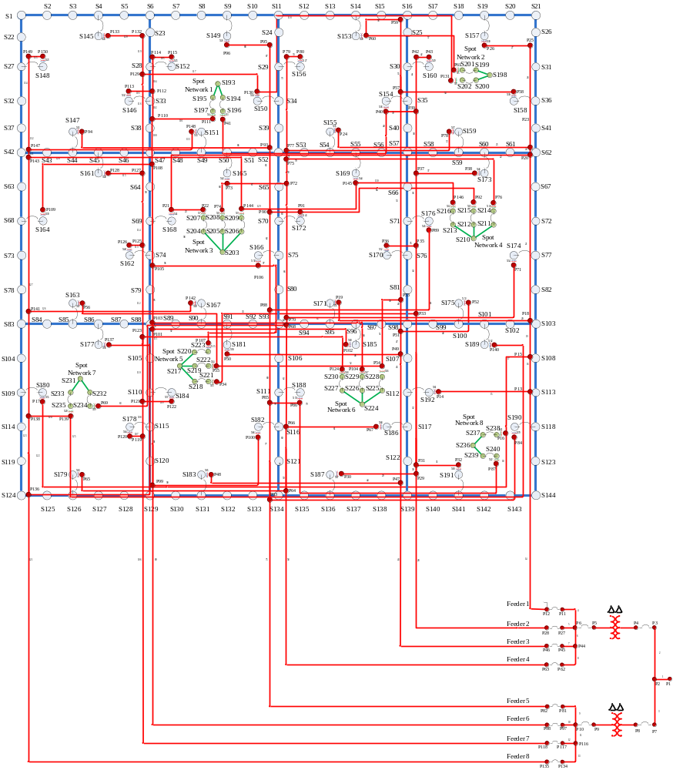
Figure 1: Complete LVNTS

Transmission (230 kV)
The LVNTS contains a small portion of the 230kV overhead transmission system that supplies the two delta-delta connected step down transformers at the substation. Node P1 is the Swing node for the system, and it is assumed to be balanced source with a line to neutral voltage of 13,943.00V, which corresponds to a line to neutral voltage of 241,499.84V. Since there are no voltage regulators in the LVNTS the swing node voltage is set above nominal.

Primary Feeders (13.2 kV)
The LVNTS contains 8 radial primary distribution feeders supplied by two substation transformers on two buses. The 8 primary feeders are delta connected and their only loads are the grid network and the 8 spot networks. Nodes P1 through P150 constitute the primary feeders. Figure 2 shows a one-line diagram of the primary feeders.

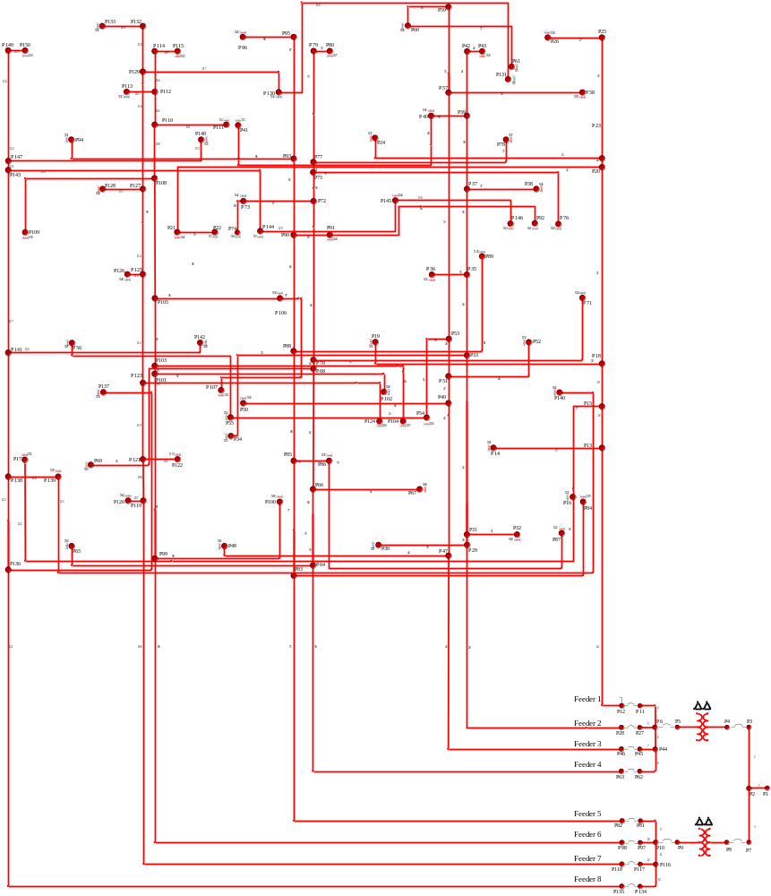
Figure 2: One-line diagram of primary distribution feeders

Grid Network (120/208V)
The LVNTS contains a single wye grounded grid network operating at 120/208V. The Grid network is supplied by the 8 primary distribution feeders through 48 1,000 kVA transformers. Nodes S1 through S192 constitute the grid network. Figure 3 shows a one-line diagram of the low voltage grid network.

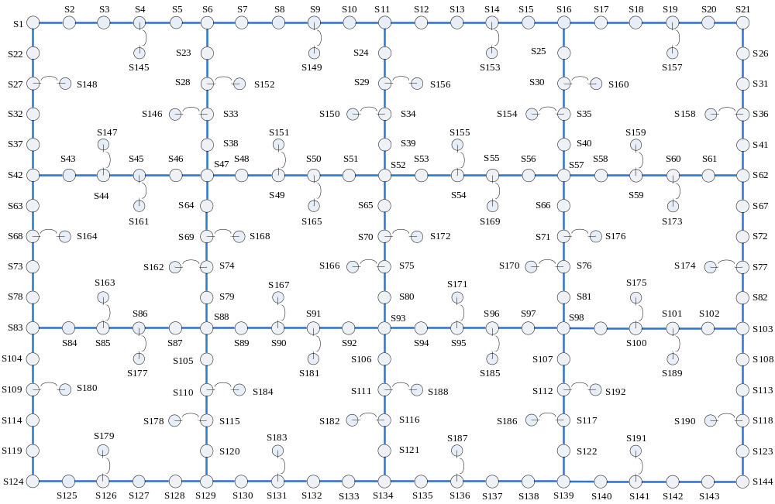
Figure 3: One-line diagram of grid network

Spot Networks (277/480V)
The LVNTS contains 8 wye grounded spot networks operating at 277/480 V. The 8 spot networks are supplied by the 8 primary distribution feeders through 20 transformers. Each spot network is supplied by 2-3 transformers each from a different primary feeder. The spot networks transformers range from 1,500 kVA to 2,500 kVA. Nodes S193 through S240 constitute the sport networks. Figure 4 shows a one-line diagram of the 8 spot networks. From Figure 4 it can be seen that each spot network is supplied by either 2 or 3 transformers, each from a different primary distribution feeder.

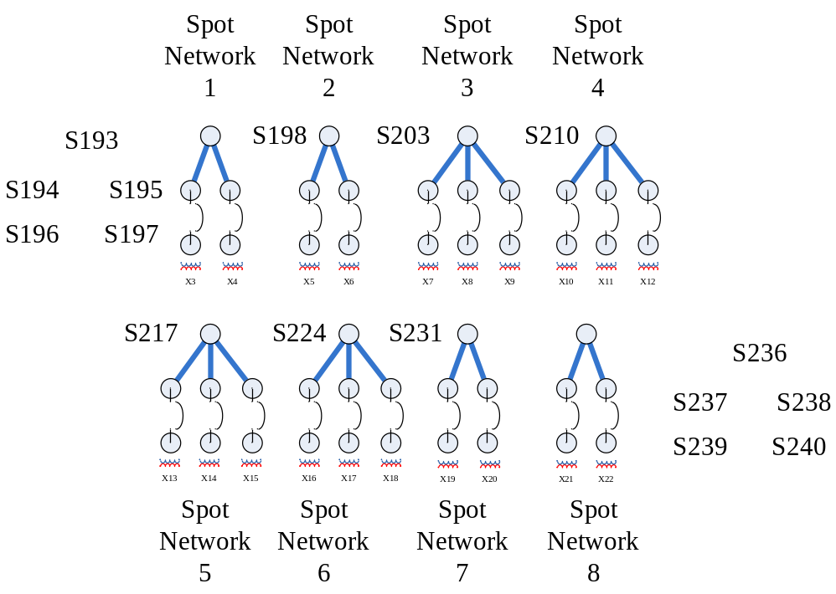
Figure 4: One-line diagram of spot networks

Network Equipment
Because of the non-radial topology, and higher current levels, of networked systems there are a number of differences in equipment that is utilized compared to radial distribution feeders.

Overhead Lines
The LVNTS is served by a 230kV overhead line. The conductor is a 397.5 kcmil “Lark” type conductor. This line serves the two substation transformers.

Primary Cables
The cables used for the primary distribution feeder are standard 15 kV class concentric neutral cables. A single conductor is used per phase, including the neutral.

Secondary Cables
The end-use loads on networked systems are generally supplied by 120/208V or 277/480V. To transfer significant amounts of power at these voltage levels requires high current levels compared to those seen in radial distribution systems. It is not uncommon for 120/208V networks to use 4-6 sets of parallel 500 kcmil conductor, giving a current rating of >2000A. The grid network and the 8 spot networks use parallel sets of cable. Since these cables are considered to be in spate conduits, there is not electromagnetic coupling between cables.

Transformers
The transformers in the LVNTS connect the 8 primary distribution feeders with the grid network and the 8 spot networks. These transformers are delta to wye-grounded and range in power rating from 1,000 kVA to 2,500 KVA. Secondary network transformers should conform to ANSI C57.12.40.

Network Protectors
Network protectors are protective devices that are designed to prevent the network grid from providing power back into the primary distribution feeders. These devices are installed on the low voltage side of transformers and are effectively reverse power devices that are designed to operate on low levels of reverse power; the charging current of a transformer primary is enough to actuate a network protector. Network Protectors should conform to ANSI C57.12.44. It is assumed that the network protectors have a resistance of 1e-6Ω.

Power Flow Solutions

Case 1: Normal Operation
Under normal operation all 8 of the primary distribution feeders are in operation. With all 8 of the feeders in operation, the voltage profile on the grid network can be seen in Figure 5.

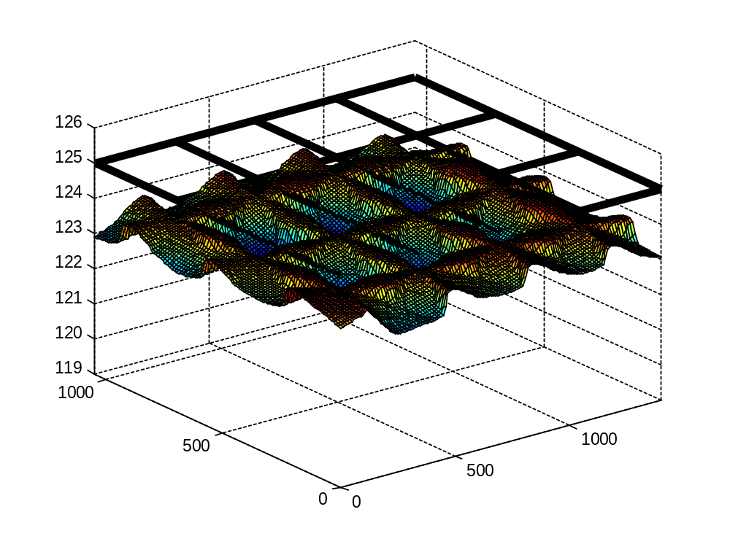
Figure 5: Case 1 Voltage Profile

Case 2: Loss of a Single Primary Distribution Feeder (Feeder 6)
When feeder 6 is removed from operation the grid network loses 7 1,000 kVA transformers and spot networks 1 and 6 each lose a single transformer. The loss of the 7 network transformer causes greater voltage drops in the network voltage plot as shown in Figure 6. Additionally, overloads are experienced in multiple locations on both transformers and cables. The maximum overloads do not exceed 127%.
In Case 2, the feeder breaker is opened, 10_sw, and this causes the network protectors associated with feeder 6 to open; 56_sw, 50_sw, 75_sw, 40_sw, 48_sw, 29_sw, 23_sw, 22_sw, and 15_sw.

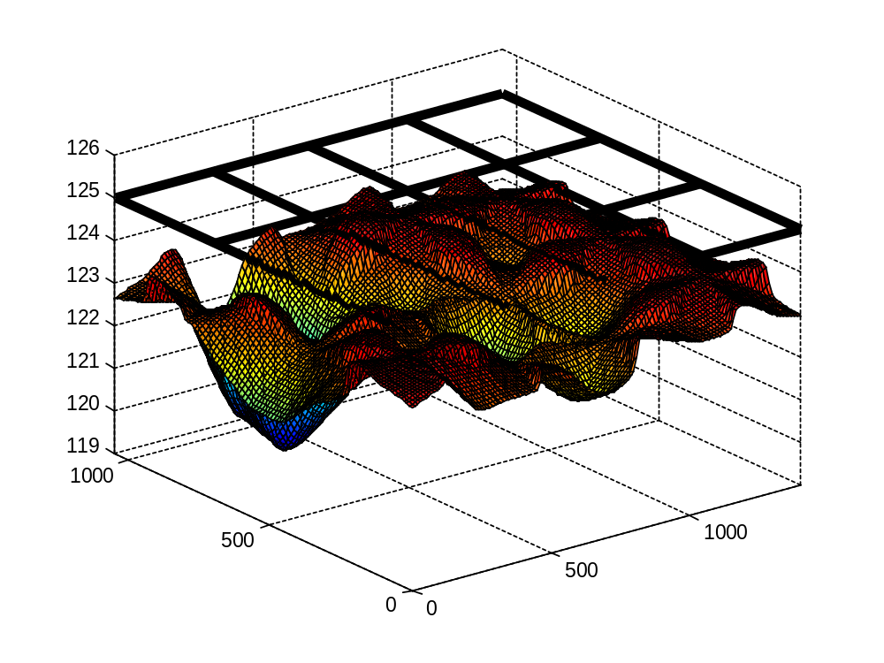
Figure 6: Case 2 Voltage Profile

Input Files
The information necessary to construct the LVNTS exists in this document and three source files; Lines.csv, Transformers.csv, and Loads.csv.

Line Segment Data:
Individual segment information can be found in Lines.csv.

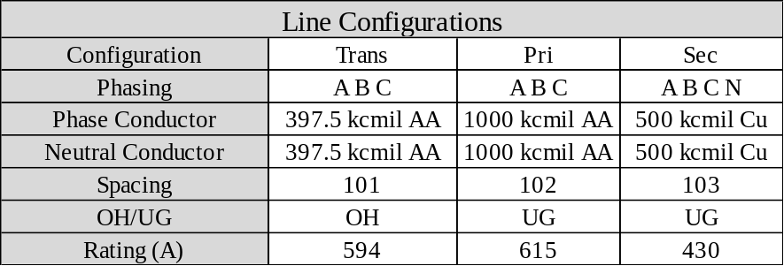

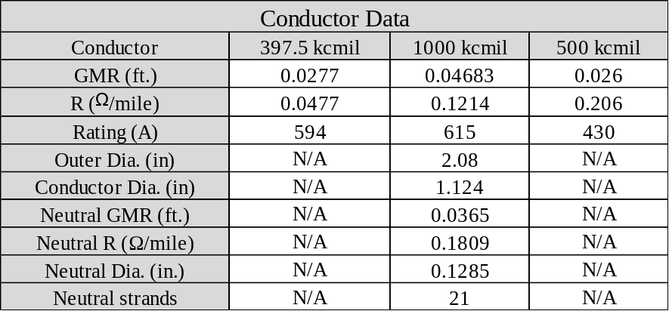

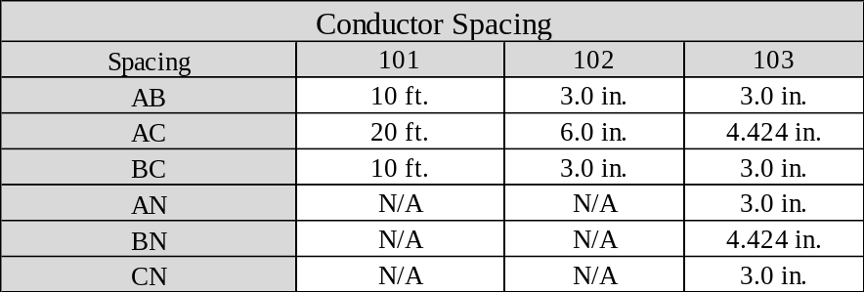

Transformer Data:
Individual transformer information can be found in Transforrmers.csv.

Load Data:
Individual load information can be found in Loads.csv. All loads are considered to use a constant power representation.

References
[1] IEEE PES Distribution Systems Analysis Subcommittee Radial Test Feeders, http://ewh.ieee.org/soc/pes/dsacom/testfeeders.html.

[2] R. C. Dugan, William H. Kersting, Sandoval Carneiro, Jr., Robert F. Arritt, and Thomas E. McDermott, “Roadmap for the IEEE PES Test Feeders”, Panel on Advances in Distribution System Analysis, Proceedings of 2009 IEEE PES Power Systems Conference and Exhibition (PSCE 2009), Seattle, March 2009.

